**BANK LOAN REPORT QUERY DOCUMENT**

1. **BANK LOAN REPORT | SUMMARY**

**KPI’s:**

**Total Loan Applications**

SELECTCOUNT(id)ASTotal_ApplicationsFROMbank_loan_data



**MTD Loan Applications**

SELECTCOUNT(id)ASTotal_ApplicationsFROMbank_loan_data

WHEREMONTH(issue_date)= 12



**PMTD Loan Applications**  
SELECTCOUNT(id)ASTotal_ApplicationsFROMbank_loan_data

WHEREMONTH(issue_date)= 11



**Total Funded Amount**

SELECTSUM(loan_amount)ASTotal_Funded_AmountFROMbank_loan_data



**MTD Total Funded Amount**

SELECTSUM(loan_amount)ASTotal_Funded_AmountFROMbank_loan_data

WHEREMONTH(issue_date)= 12



**PMTD Total Funded Amount**

SELECTSUM(loan_amount)ASTotal_Funded_AmountFROMbank_loan_data

WHEREMONTH(issue_date)= 11



**Total Amount Received**

SELECTSUM(total_payment)ASTotal_Amount_CollectedFROMbank_loan_data



**MTD Total Amount Received**

SELECTSUM(total_payment)ASTotal_Amount_CollectedFROMbank_loan_data

WHEREMONTH(issue_date)= 12



**PMTD Total Amount Received**

SELECTSUM(total_payment)ASTotal_Amount_CollectedFROMbank_loan_data

WHEREMONTH(issue_date)= 11



**Average Interest Rate**

SELECTAVG(int_rate)*100 ASAvg_Int_RateFROMbank_loan_data



**MTD Average Interest**

SELECTAVG(int_rate)*100 ASMTD_Avg_Int_RateFROMbank_loan_data

WHEREMONTH(issue_date)= 12



**PMTD Average Interest**

SELECTAVG(int_rate)*100 ASPMTD_Avg_Int_RateFROMbank_loan_data

WHEREMONTH(issue_date)= 11



**Avg DTI**

SELECTAVG(dti)*100 ASAvg_DTIFROMbank_loan_data



**MTD Avg DTI**

SELECTAVG(dti)*100 ASMTD_Avg_DTIFROMbank_loan_data

WHEREMONTH(issue_date)= 12



**PMTD Avg DTI**

SELECTAVG(dti)*100 ASPMTD_Avg_DTIFROMbank_loan_data

WHEREMONTH(issue_date)= 11



**GOOD LOAN ISSUED**

**Good Loan Percentage**

SELECT

(COUNT(CASEWHENloan_status='Fully Paid'ORloan_status='Current'THEN id END)* 100.0)/

COUNT(id)ASGood_Loan_Percentage

FROMbank_loan_data



**Good Loan Applications**

SELECTCOUNT(id)ASGood_Loan_ApplicationsFROMbank_loan_data

WHEREloan_status='Fully Paid'ORloan_status='Current'



**Good Loan Funded Amount**

SELECTSUM(loan_amount)ASGood_Loan_Funded_amountFROMbank_loan_data

WHEREloan_status='Fully Paid'ORloan_status='Current'



**Good Loan Amount Received**

SELECTSUM(total_payment)ASGood_Loan_amount_receivedFROMbank_loan_data

WHEREloan_status='Fully Paid'ORloan_status='Current'



**BAD LOAN ISSUED**

**Bad Loan Percentage**

SELECT

(COUNT(CASEWHENloan_status='Charged Off'THEN id END)* 100.0)/

COUNT(id)ASBad_Loan_Percentage

FROMbank_loan_data



**Bad Loan Applications**

SELECTCOUNT(id)ASBad_Loan_ApplicationsFROMbank_loan_data

WHEREloan_status='Charged Off'



**Bad Loan Funded Amount**

SELECTSUM(loan_amount)ASBad_Loan_Funded_amountFROMbank_loan_data

WHEREloan_status='Charged Off'



**Bad Loan Amount Received**

SELECTSUM(total_payment)ASBad_Loan_amount_receivedFROMbank_loan_data

WHEREloan_status='Charged Off'



**LOAN STATUS**

SELECT

loan_status,

COUNT(id)ASLoanCount,

SUM(total_payment)ASTotal_Amount_Received,

SUM(loan_amount)ASTotal_Funded_Amount,

AVG(int_rate* 100)ASInterest_Rate,

AVG(dti* 100)AS DTI

FROM

bank_loan_data

GROUPBY

loan_status

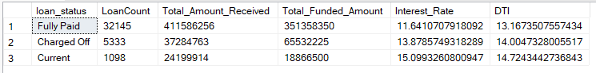

SELECT

loan_status,

SUM(total_payment)ASMTD_Total_Amount_Received,

SUM(loan_amount)ASMTD_Total_Funded_Amount

FROMbank_loan_data

WHEREMONTH(issue_date)= 12

GROUPBYloan_status

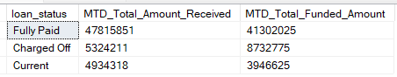

1. **BANK LOAN REPORT | OVERVIEW**

**MONTH**

SELECT

MONTH(issue_date)ASMonth_Munber,

DATENAME(MONTH,issue_date)ASMonth_name,

COUNT(id)ASTotal_Loan_Applications,

SUM(loan_amount)ASTotal_Funded_Amount,

SUM(total_payment)ASTotal_Amount_Received

FROMbank_loan_data

GROUPBYMONTH(issue_date),DATENAME(MONTH,issue_date)

ORDERBYMONTH(issue_date)

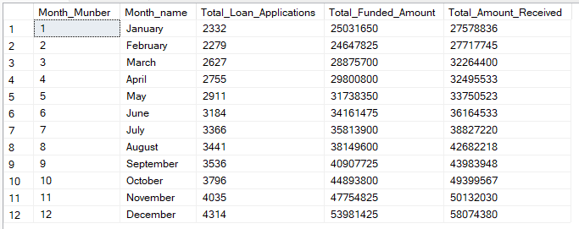

**STATE**

SELECT

address_stateASState,

COUNT(id)ASTotal_Loan_Applications,

SUM(loan_amount)ASTotal_Funded_Amount,

SUM(total_payment)ASTotal_Amount_Received

FROMbank_loan_data

GROUPBYaddress_state

ORDERBYaddress_state

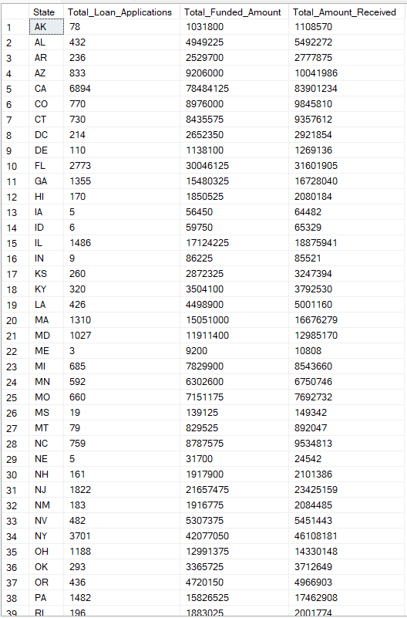

**TERM**

SELECT

term AS Term,

COUNT(id)ASTotal_Loan_Applications,

SUM(loan_amount)ASTotal_Funded_Amount,

SUM(total_payment)ASTotal_Amount_Received

FROMbank_loan_data

GROUPBY term

ORDERBY term

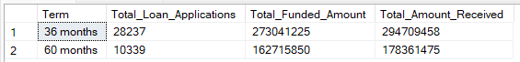

**EMPLOYEE LENGTH**

SELECT

emp_lengthAS Employee_Length,

COUNT(id)ASTotal_Loan_Applications,

SUM(loan_amount)ASTotal_Funded_Amount,

SUM(total_payment)ASTotal_Amount_Received

FROMbank_loan_data

GROUPBYemp_length

ORDERBYemp_length

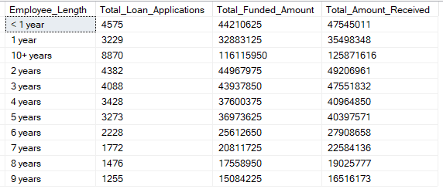

**PURPOSE**

SELECT

purpose AS PURPOSE,

COUNT(id)ASTotal_Loan_Applications,

SUM(loan_amount)ASTotal_Funded_Amount,

SUM(total_payment)ASTotal_Amount_Received

FROMbank_loan_data

GROUPBY purpose

ORDERBY purpose

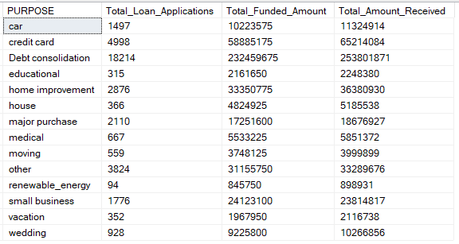

**HOME OWNERSHIP**

SELECT

home_ownershipASHome_Ownership,

COUNT(id)ASTotal_Loan_Applications,

SUM(loan_amount)ASTotal_Funded_Amount,

SUM(total_payment)ASTotal_Amount_Received

FROMbank_loan_data

GROUPBYhome_ownership

ORDERBYhome_ownership

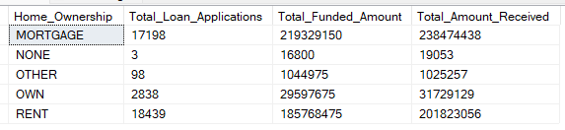

*Note: We have applied multiple Filters on all the dashboards. You can check the results for the filters as well by modifying the query and comparing the results.*

*For e.g*

*See the results when we hit the Grade A in the filters for dashboards.*

*SELECT*

*purpose AS PURPOSE,*

*COUNT(id)ASTotal_Loan_Applications,*

*SUM(loan_amount)ASTotal_Funded_Amount,*

*SUM(total_payment)ASTotal_Amount_Received*

*FROMbank_loan_data*

*WHERE grade ='A'*

*GROUPBY purpose*

*ORDERBY purpose*